STM32CubeIDE first launch

Help:

* Check for Target Selector Device Database Update

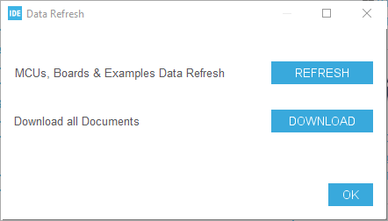

Click both “Refresh” and “Download”. After clicking the “Download” button something alike this would pop-up:

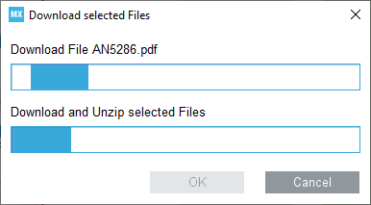

This would take a while. Wait till it finishes. Might take a few times to repeat the process if any error occur.

* Manage Embedded Software Packages

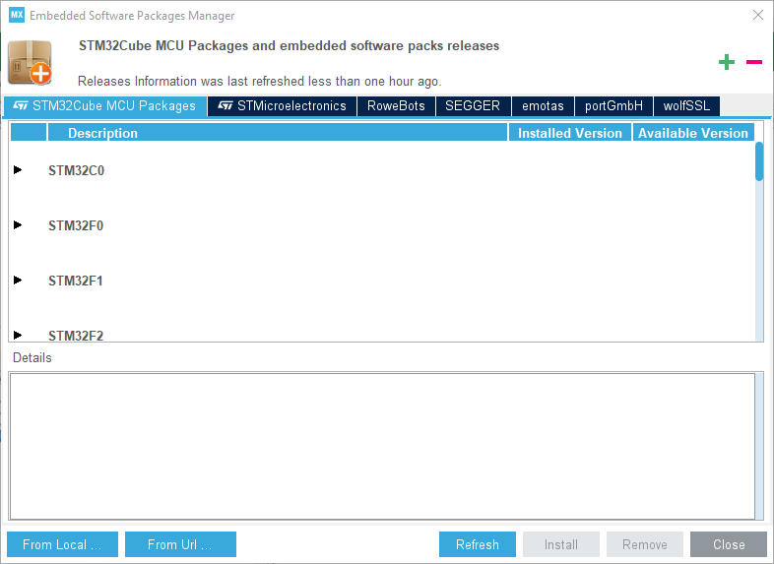

Here select the expected target, let say STM32F1 series:

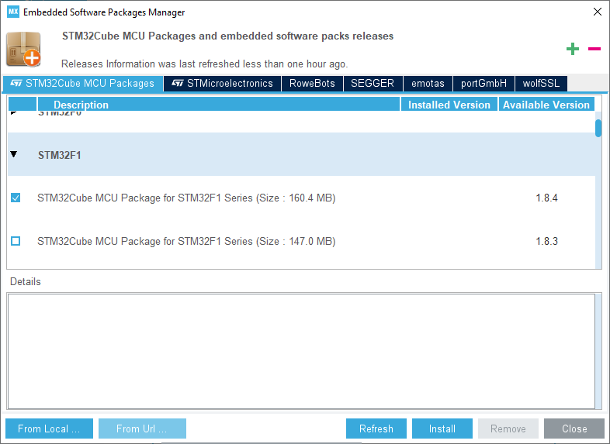

And TouchGFX and X-Cube-AI:

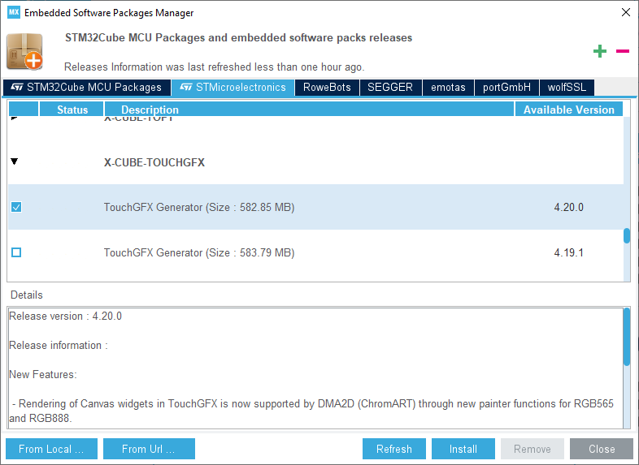

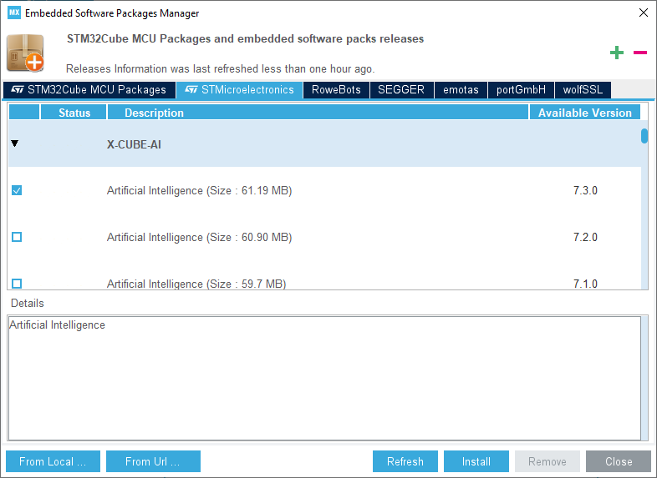

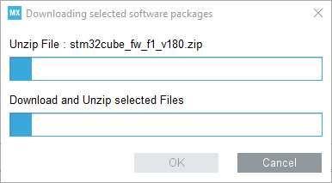

For some Packages you might need to accept the licence:  
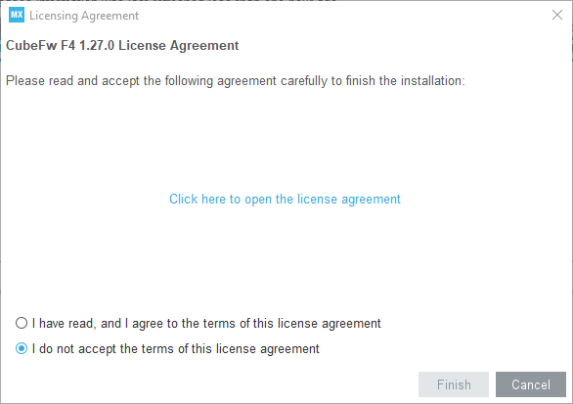

Add UTF:

Window->Preferences->General->Workspace->Text file encoding

Useful for Cyrylic comments

Alternatively, add command

gcc -fexec-charset=CP1251

to MCU GCC Compiler (more info: <https://gcc.gnu.org/onlinedocs/cpp/Invocation.html#index-fexec-charset>)